* **Activity 1**:

Using the UNION Operator

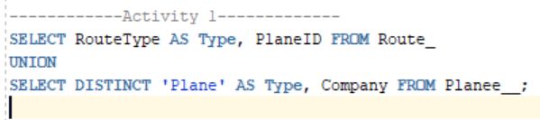

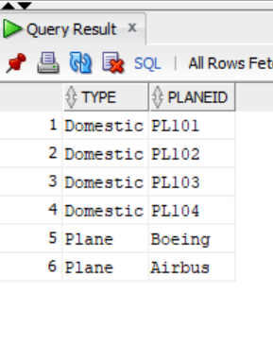

OUTPUT: